*SQL PROJECT*

*ON*

*OLYMPIC HISTORY DATABASE*

*BY: DIVYA SRI. B*

1. SHOW DATABASES AND USE DATABASES

QUERY:

1. Show Databases;
2. Use Databases;

OUTPUT:

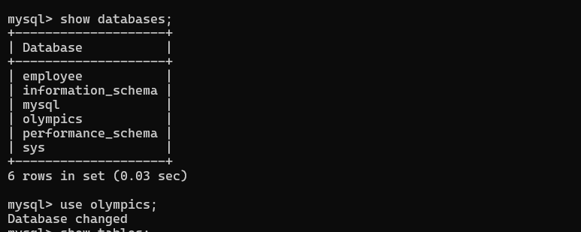

1. SHOW TABLES:

QUERY:

Show tables;

OUTPUT:

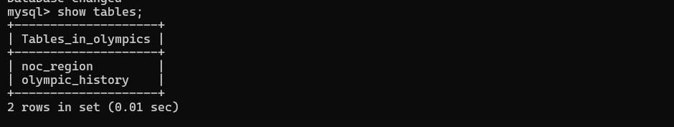

1. CREATE TABLES

CREATE TABLE OLYMPIC_HISTORY:

QUERY:

Create table Olympic_history(id int primary key,

name varchar (20) not null, sex varchar (10), age varchar (5),

height varchar (10), weight varchar (10), team varchar (20),

noc varchar (20), games varchar (20), year int, season varchar (20), city varchar (20), sports varchar (25), event varchar (25), medal varchar (10));

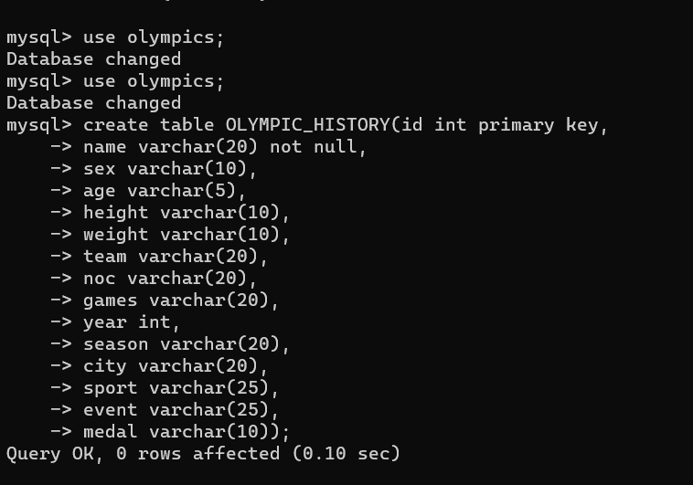OUTPUT:

TO VIEW TABLE:

desc Olympic_ history;

OUTPUT:

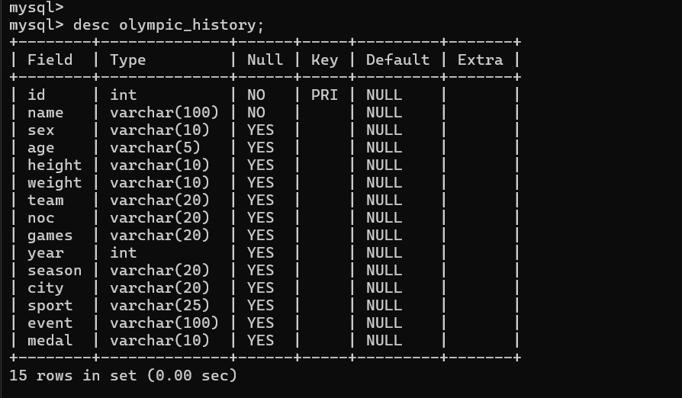

CREATE TABLE NOC_REGION:

QUERY:

Create table noc_region (noc varchar (10), region varchar (40), notes varchar (40));

To view table:

desc noc_region;

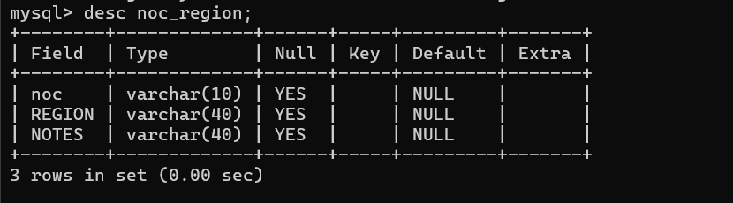

4.INSERT THE VALUES OR DATAS

QUERY FOR TABLE(OLYMPIC_HISTORY):

Syntax:

Insert into table_ name values (column1 datatype1, column2 datatype2, column3 datatype3….);

OUTPUT:

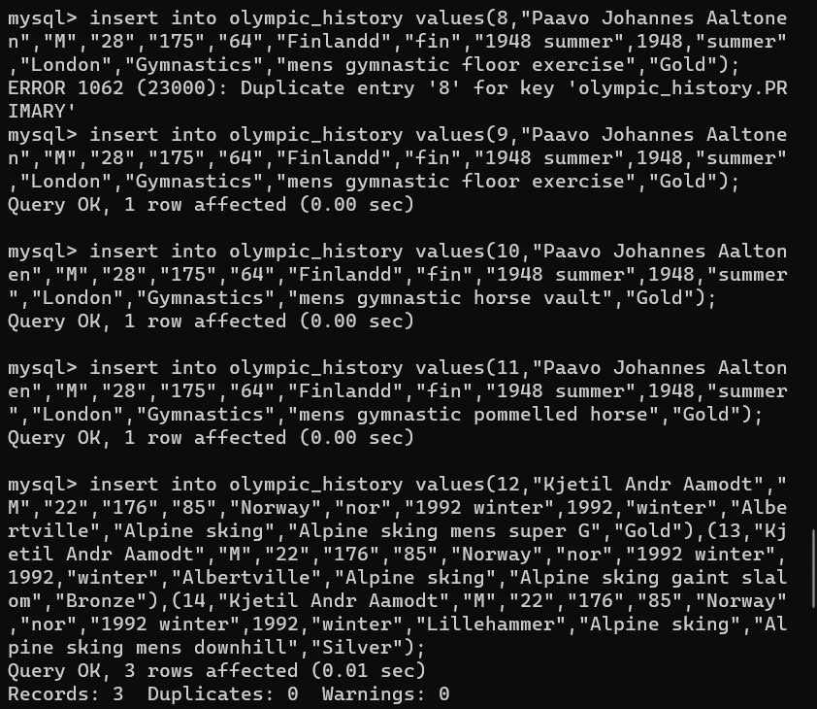

QUERY FOR TABLE(NOC_REGION):

Insert into noc_region values (column1 datatype1, column2 datatype2, column3 datatype3….);

OUTPUT:

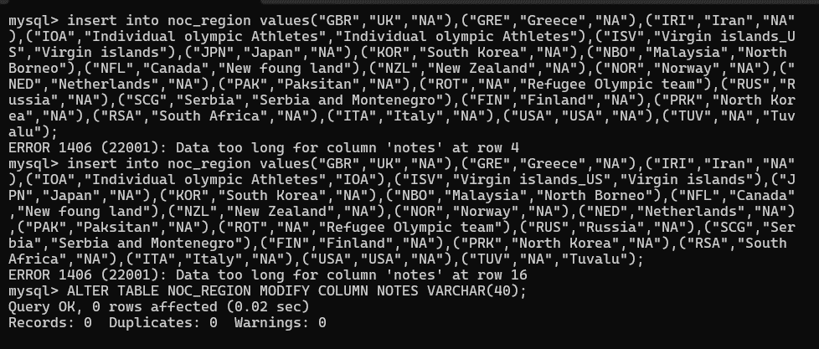

5.TO VIEW THE INSERTED TABLE WITH VALUES

QUERY:

Here we use Select query.

Select * from Olympic_history;

Output:

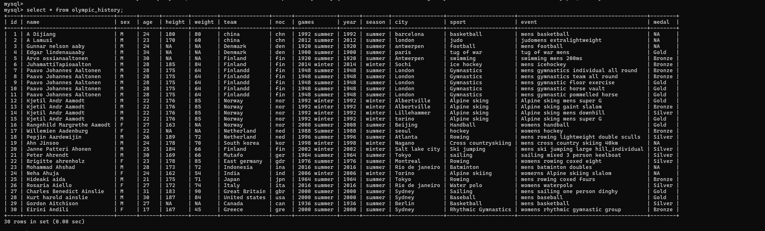

To view noc_region table:

QUERY:

Select * from noc_region;

OUTPUT:

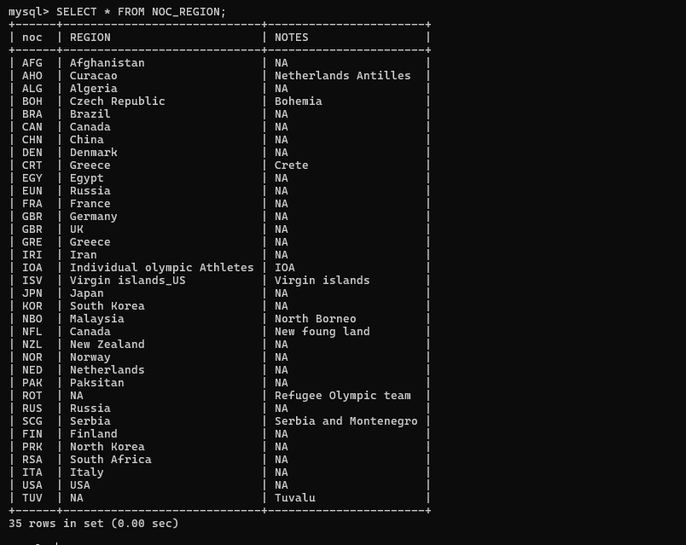

1. DDL & DML COMMANDS:

DDL (Data Definition Language):

1. Create
2. Drop
3. Truncate
4. Alter

DML (Data Manipulating Language):

1. Update
2. Insert
3. Delete

DQL (Data Query Language):

1. Select

Update command:

* The Update statement allows you to modify existing records in the table based on specified conditions.

QUERY:

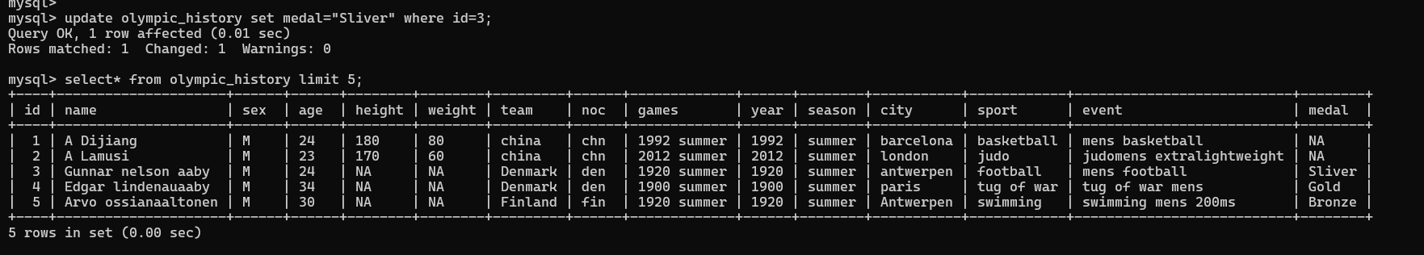 Update Olympic _history set medal=” Sliver” where id=3;

Delete command:

* The Delete command in SQL is used to remove rows from a table based on specified conditions.

QUERY:

Delete from olympic_history where id=30;

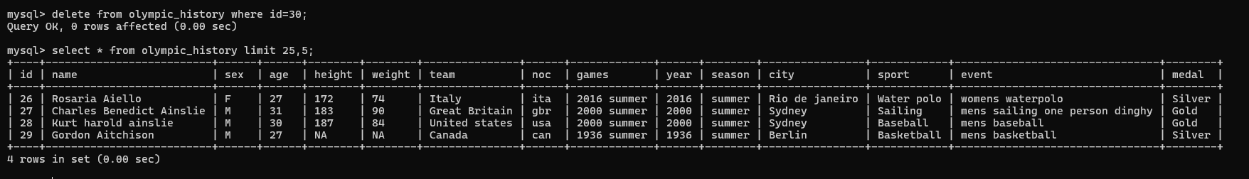OUTPUT:

Alter command/ Alter Constraints:

* The Alter command in SQL is used to modify an existing database object, such as a table, to add, modify, or remove columns, constraints or indexes.

QUERY: To drop a constraint (primary key)

Alter table Olympic_history drop primary key;

Output:

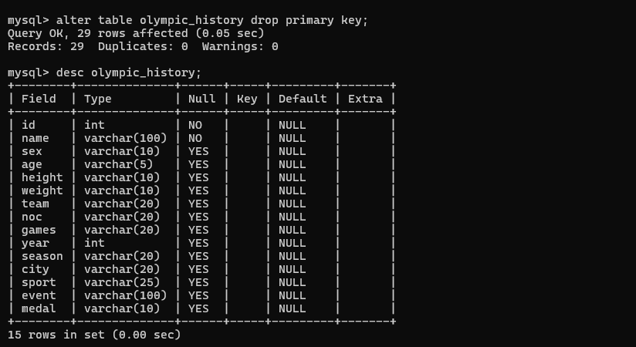

QUERY: To add a constraint (primary key)

Alter table Olympic_history add primary key(id);

OUTPUT:

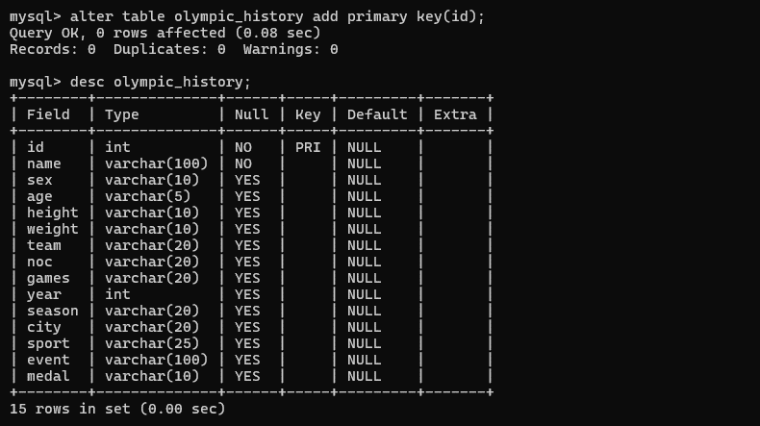

QUERY: To modify column using Alter

Alter table noc_region modify column noc varchar(5);

OUPUT:

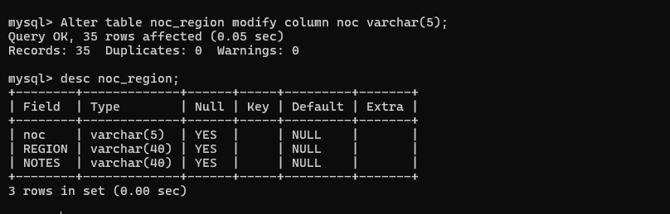

Query: To rename column using alter

Alter table Olympic_history rename column name to player_name;

OUTPUT:

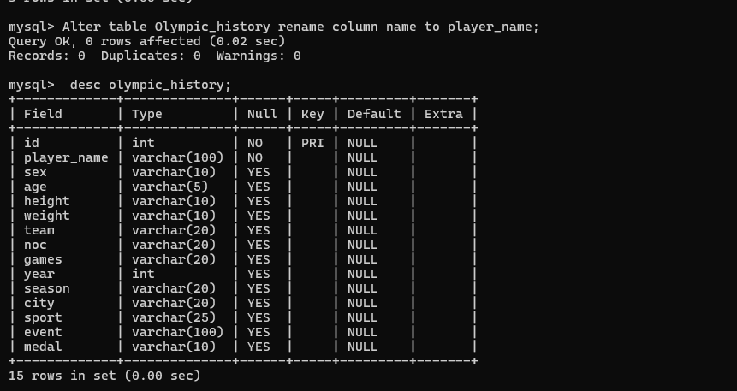

QUERY: To Add column using Alter

Alter table noc_region add column p_id;

OUTPUT:

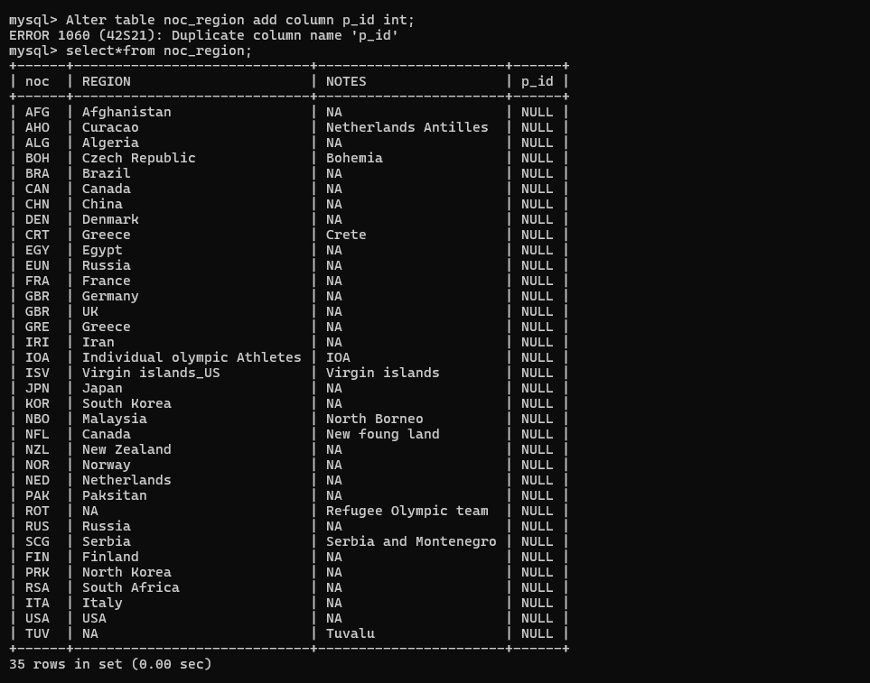

Query: To drop a column using Alter

Alter table noc_region drop column p_id;

OUTPUT:

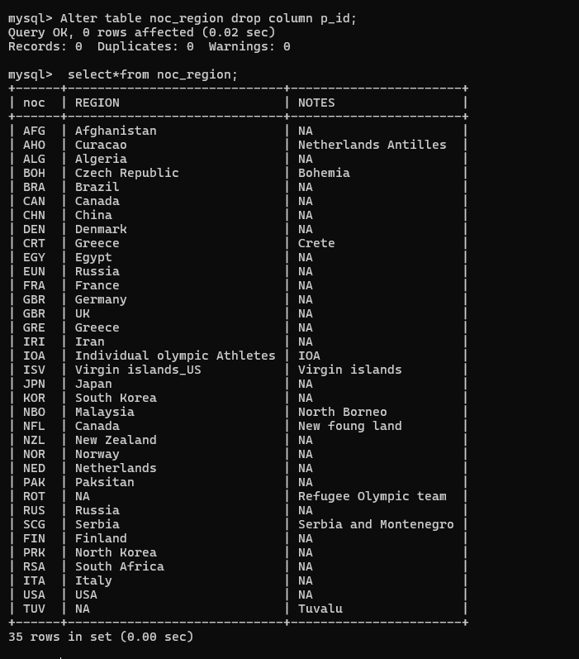

7.SELECT COMMAND

1. SELECT ALL COLUMNS FROM TABLE

QUERY: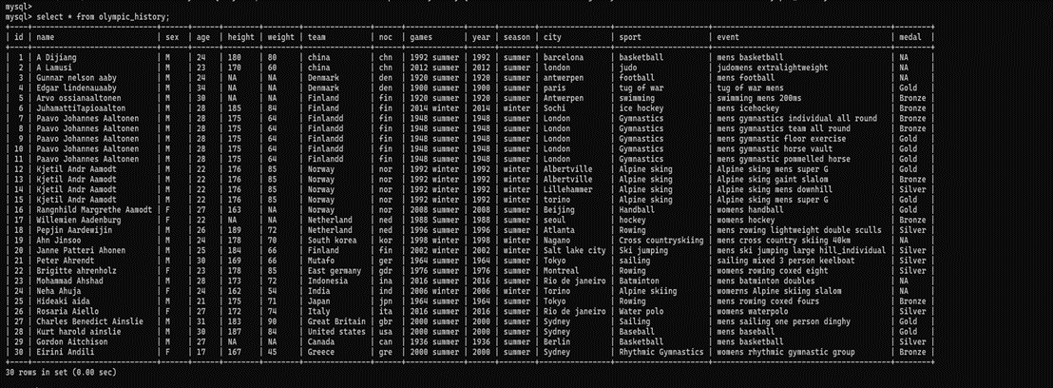 Select * from Olympic_ history;

OUTPUT:

1. SELECT PARTICULAR COLUMN FROM TABLE

QUERY:

Select player_ name, team, event, medal from Olympic_ history;

OUTPUT:

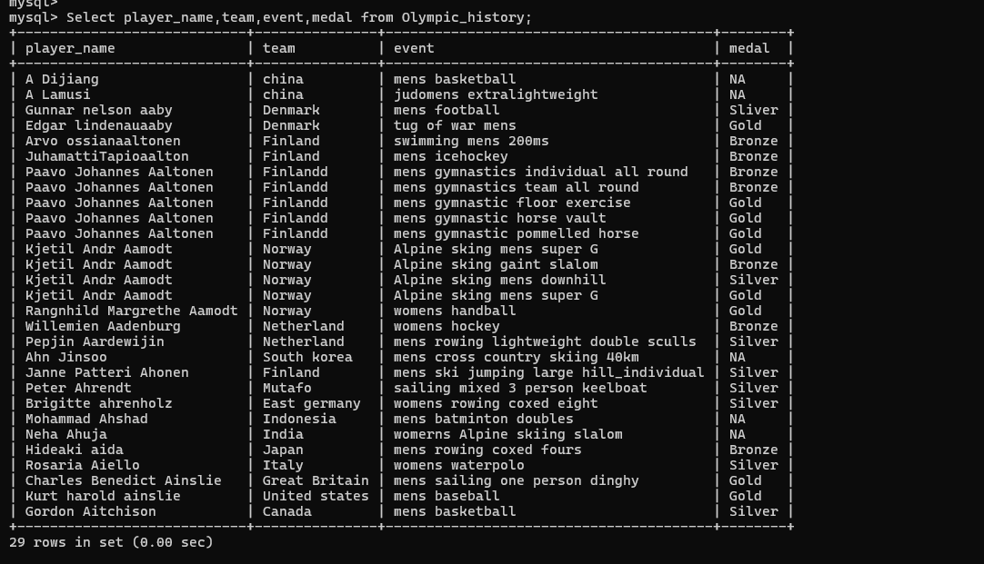

1. SELECT WITH CONDITION:

QUERY:

Select * from Olympic_ history where medal= ’Gold’;

Select* from Olympic_ history where sport= ’basketball’;

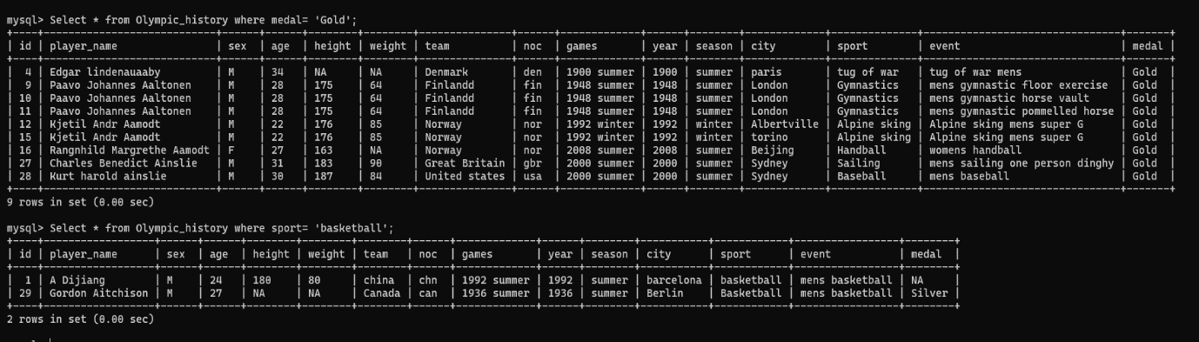OUTPUT:

QUERY:

Select *from Olympic_ history where age< ‘25’;

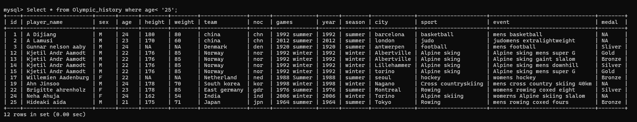OUTPUT:

1. SELECT USING AND PERATOR

QUERY:

Select * from Olympic_history where sex =’M’ AND age>’28’;

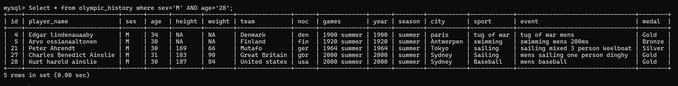OUTPUT:

1. SELECT SING OR OPERTOR

QUERY:

Select * from Olympic_history where season=’summer’ OR medal=’Gold’;

OUTPUT:

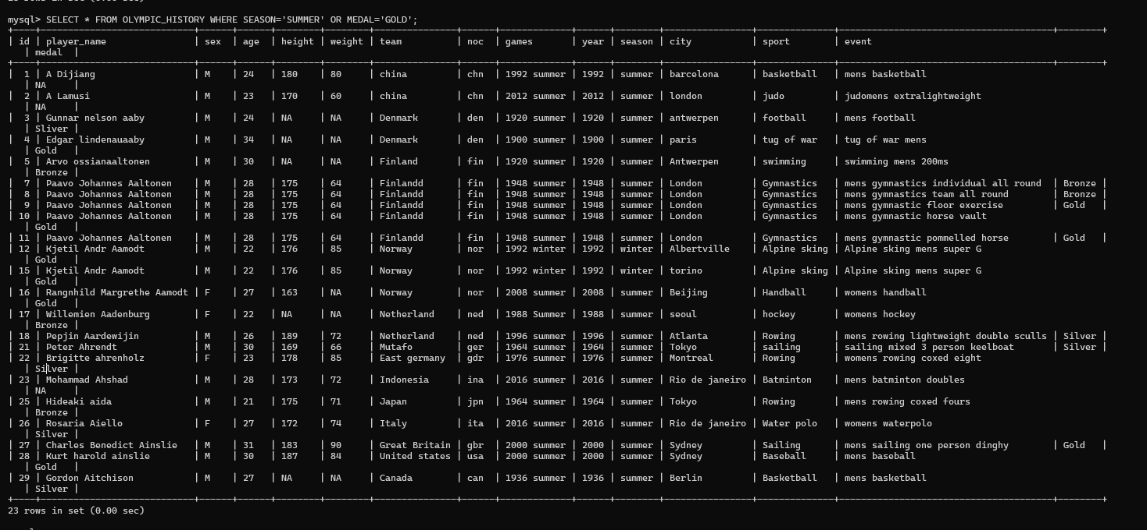

1. SELECT USING NOT OPERATORS

QUERY:

SELECT * FROM NOC_REGION WHERE NOT REGION=’CANADA’ AND NOTES=’NA’;

OUTPUT:

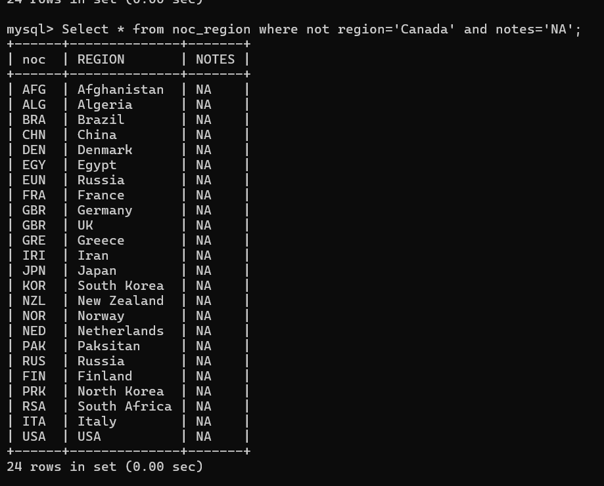

1. SELECT USING RANGE OPPERATOR(BETWEEN)

QUERY:

Select * from Olympic_history where age between ‘25’ and ‘35’ limit 5;

OUTPUT:

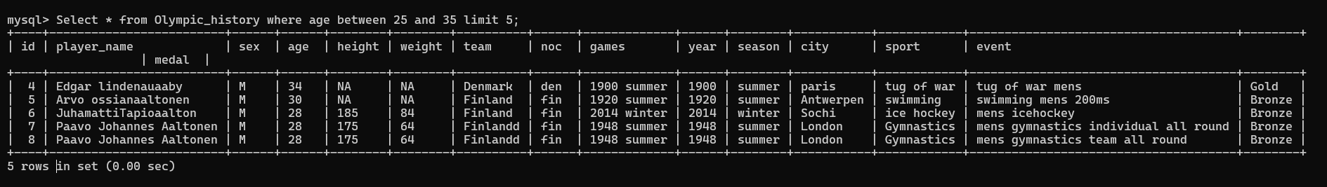

1. SELECT USING LIST OPERATOR

QUERY:

Select * from olympic_history where year in(1948,1999);

OUTPUT:

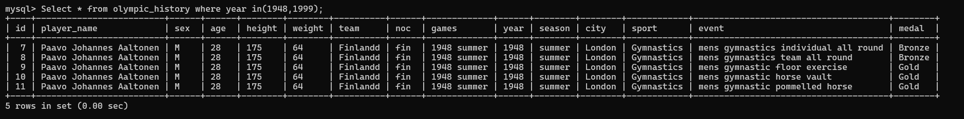

QUERY:

Select * from Olympic_history where year not in (1948,1999);

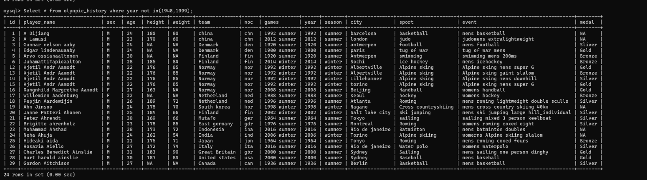OUTPUT:

1. SELECT USING LIKE OPERATOR

QUERY:

Select * from Olympic_history where player_name like “%a”;

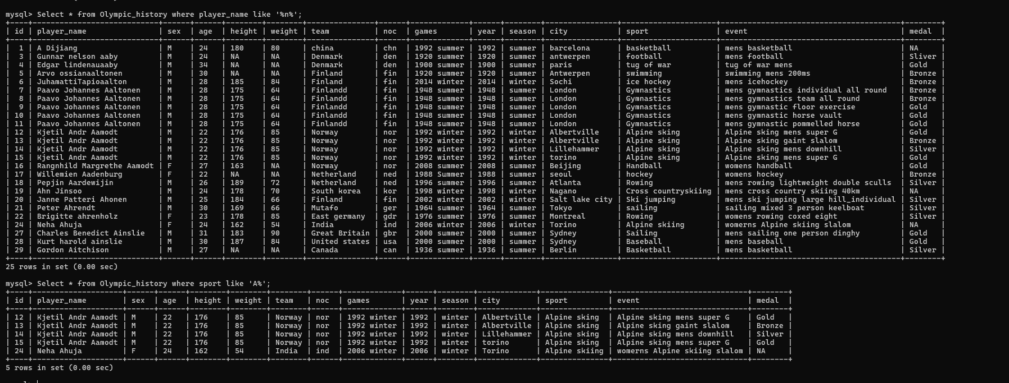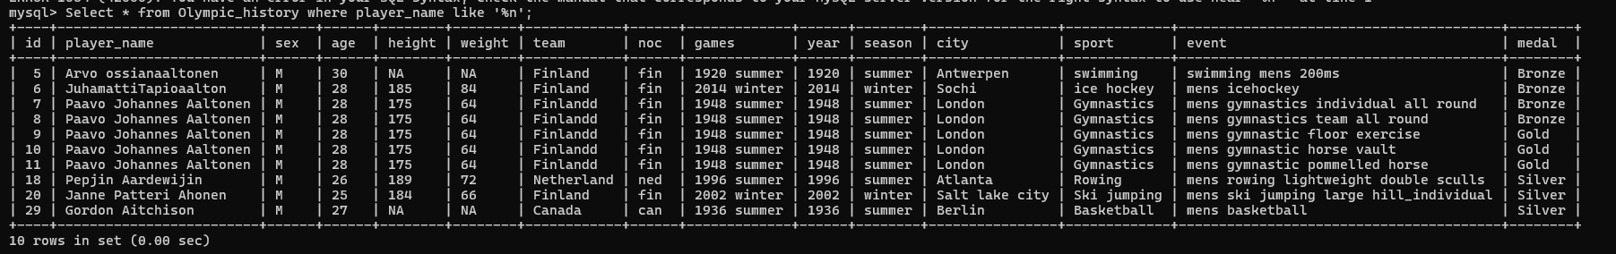OUTPUT:

1. SELECT COMMAND USING DISTINCT

QUERY:

Select distinct notes from noc_ region;

Select distinct sport from Olympic_ history;

OUTPUT:

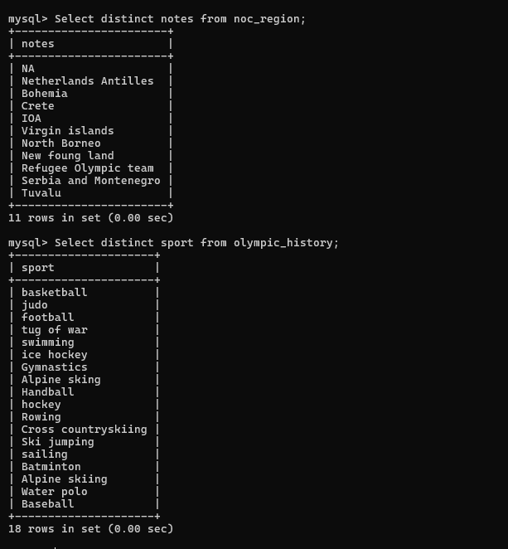

1. AGGREGATE FUNCTIONS
2. SUM
3. AVERAGE
4. COUNT
5. MIN
6. MAX
7. SUM

QUERY:

Select sum(weight) from Olympic_ history;

OUTPUT:



1. AVERAGE

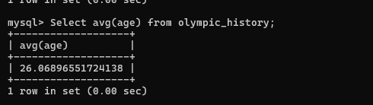

1. COUNT

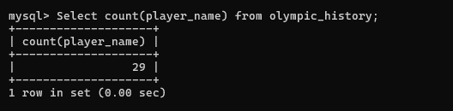

1. MIN

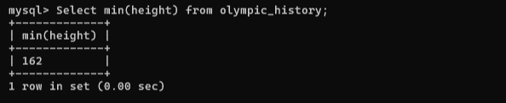

1. MAX

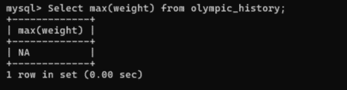

1. GROUP BY

* The GROUP BY operations is used in SQL to group rows from a table based on the values in one or more columns.

QUERY:

Select medal, count(*) as player_ achievements from Olympic_ history group by medal;

OUTPUT:

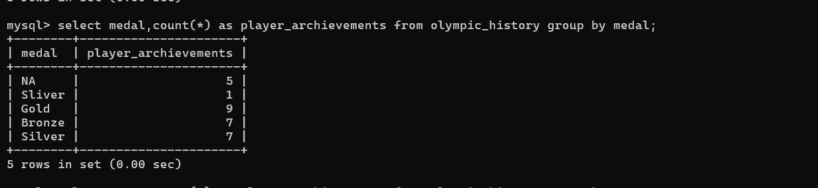

1. ORDER BY

* The ORDER BY Clause is used to sort the result set based on one or more columns in either ascending or descending order.

QUERY:

Select* from Olympic_ history order by age;

OUTPUT:

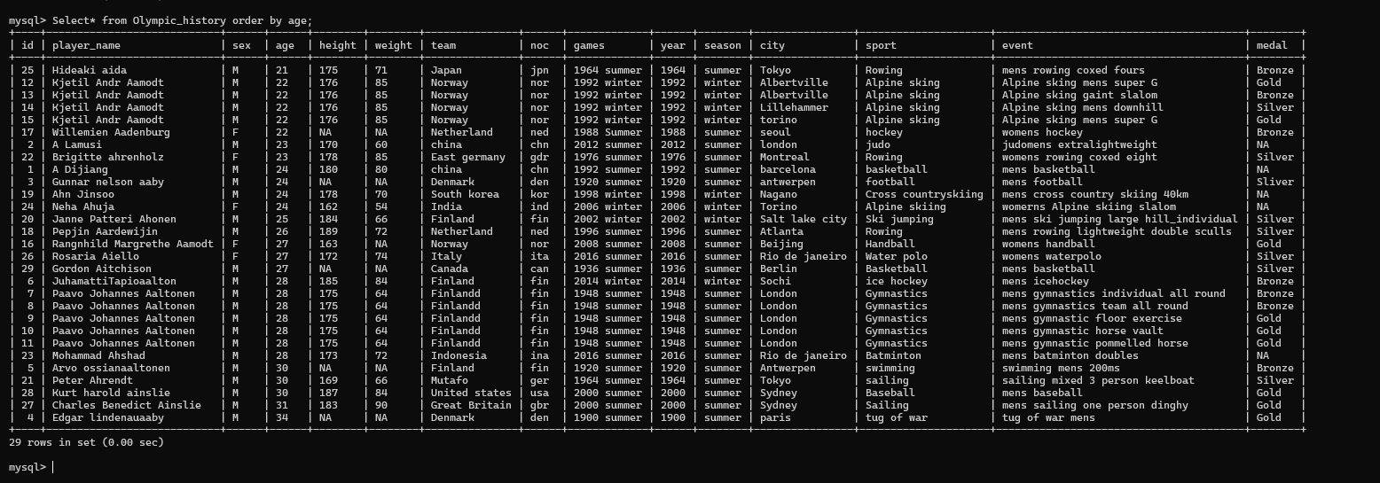

1. SUB QUERIES

* Subqueries can be used to perform complex queries and retrieve data based on the results of inner queries.

Query:

Select player_ name, games from Olympic_ history where team='Norway' and sex='M' in (select team from Olympic_ history where sport='Alphine skiing');

OUTPUT:

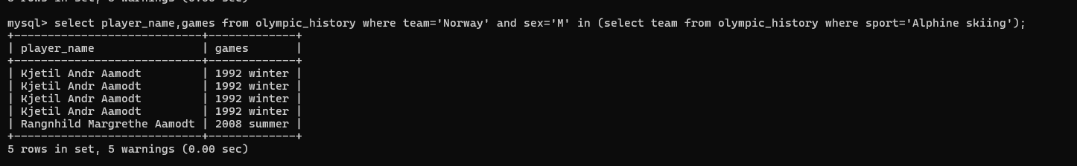

1. Joins

* Joins are used to combine data from multiple tables based on related columns.
* Joins helps to retrieve information that is distributed across the different tables in a more meaningful and consolidated manner.

QUERY:

Select Olympic_history. id, olympic_history. player_ name, Olympic_ history. noc, noc_region. noc, noc_region. region from Olympic_ history join noc_region on Olympic_ history. noc = noc_ region.noc;

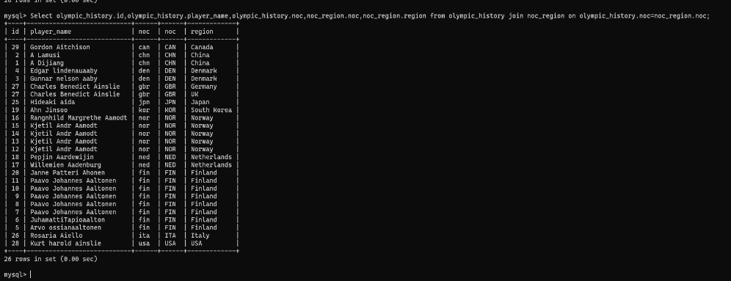OUTPUT:

THANK YOU